**Bayesian Network Design Workshop**

Bayesian networks are used to model complex problems in an easily understandable and intuitive manner. They consist of ideas that are linked together, such as water use to yield. Each idea is called a node, and each node has a table of how it interacts to the nodes it is connected to, for example:

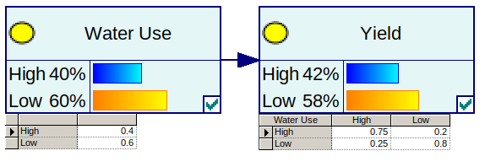In this example we say that 2 in 5 vineyards likely use more water than others; that 3 out of 4 vineyards that use more water may have a higher yield and 1 out of 5 that use lower water may still have a higher yield. These measures allow the calculation of the proportion of vineyards that may have a higher yield. The end result will be models informed by experts and data to help describe the affects both accurately and with proper causation (Note: high/low thresholds have to be defined).

What is this workshop all about?

* Connecting important vineyard outcomes to probable causes.
* Attributing levels of importance to different vineyard operations and resources.
* Relating these connections and outcomes to sustainability.

What do we hope to achieve?

* A better understanding of what drives sustainability.
* A “network map” of probable cause and effects for vineyards.
* Vineyard sustainability score cards based on expert information and other evidence.

What will you have to do?

* Construct a “network map” of important factors affecting different aspects of sustainability.
* Weigh in on the level of influence/importance a vineyard factor has on other factors.
* Debate the influence of vineyard factors on the economic, social and environmental outcomes.
* Develop scenarios (sets of values for factors) for the model that are important for the assessment of sustainability.

This workshop will commence with short introductions. Participants will be introduced to an example Bayesian Network that predicts yield. We will show how these networks can be improved using expert knowledge and where this fits into the research that is being conducted on sustainable viticulture.

Participants will then be introduced to a “straw man” Bayesian Network linking vineyard elements to sustainability. This Network will consist of well known vineyard factors such as water and fuel. Where possible each vineyard factor will be limited to strong/good versus weak/bad states and the likelihood of each state is estimated. Participants will be asked to assess the network structure, add new nodes if necessary and fill out the impact or likelihood of the nodes states.

As vineyards are unique and complicated entities, we understand that not one model fits all. We want to embrace this as part of the problem and intend to include nodes/elements that may only apply to some vineyards but not all. In the workshop we will aim to create a single general model. Multiple models can be created later, different ones for more nuanced situations using the inputs from this session.

**Extra material:**

**Example Bayesian Network (Australian diary industry case study)**

Below is an example of an expert informed model for the diary industry. Connecting economic, social and environmental factors to three major outcomes: Farm, Factory and Market. Each of the economic, social and environmental factors “open up” into their own networks comprised of important factors related to these aspects.

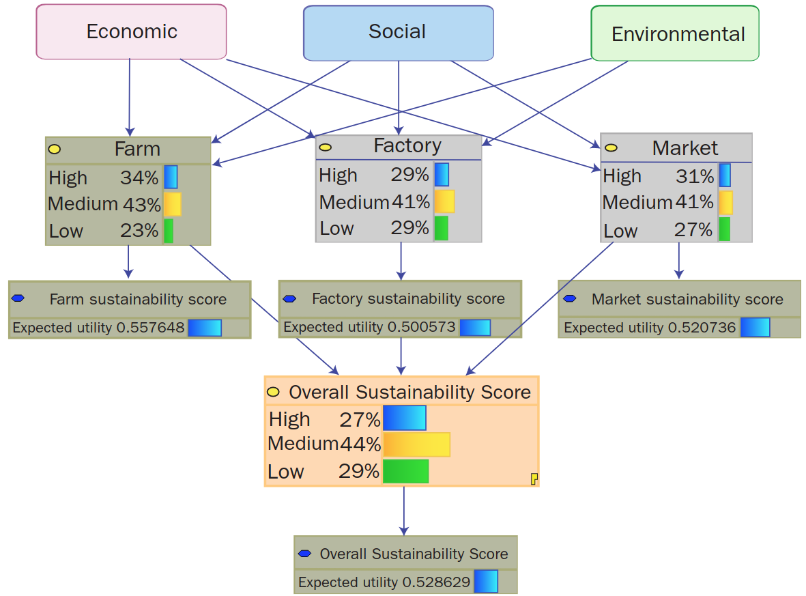

**Figure 1:** This is an example of different nodes depicting the connection between outcomes in the dairy industry and overall sustainability. The example is taken from *A Triple Bottom Line Planning Tool for Measuring Sustainability* by Laurie Buys, Kerrie Mengersen, Sandra Johnson, Neil Van Buuren and Evonne Miller.

Here, an example of the structure for each of the three sub-networks making up the Economic, Social and Environmental measures of sustainability for the diary industry are displayed:

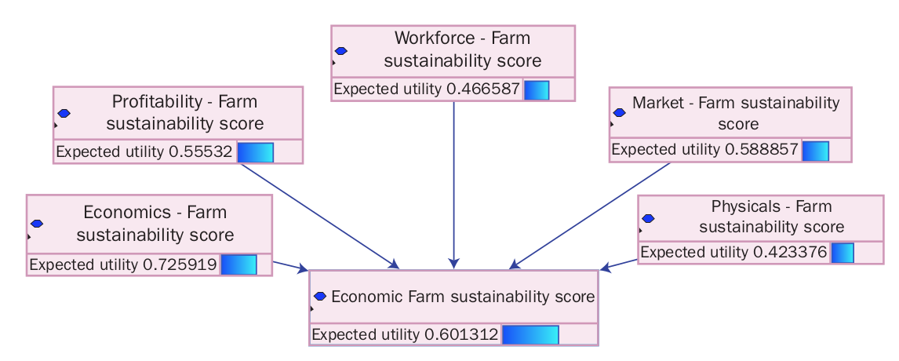**Figure 2:** Economic elements of sustainability for the diary industry.

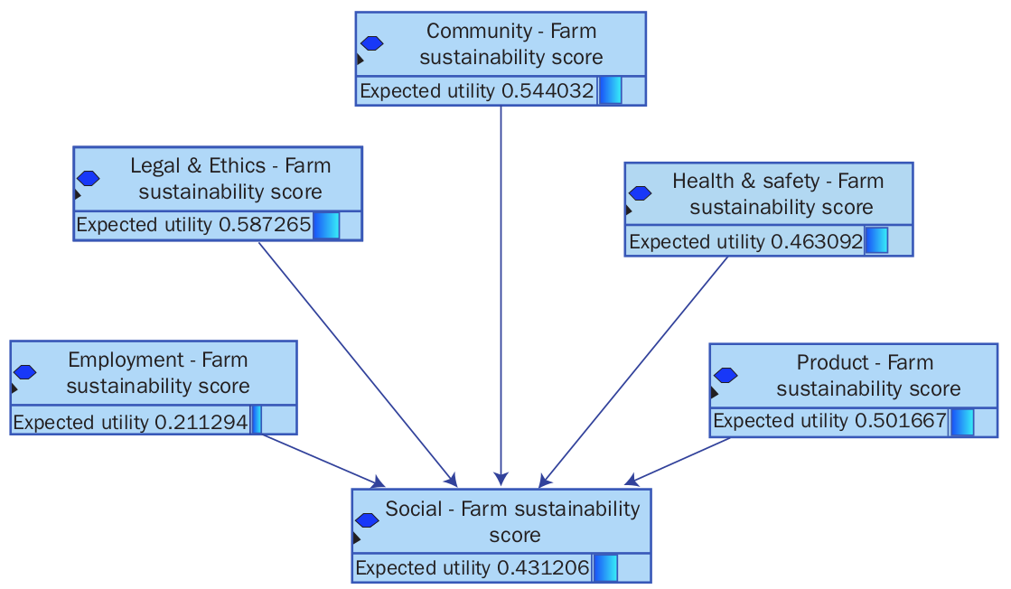**Figure 3:** Social elements of sustainability for the diary industry.

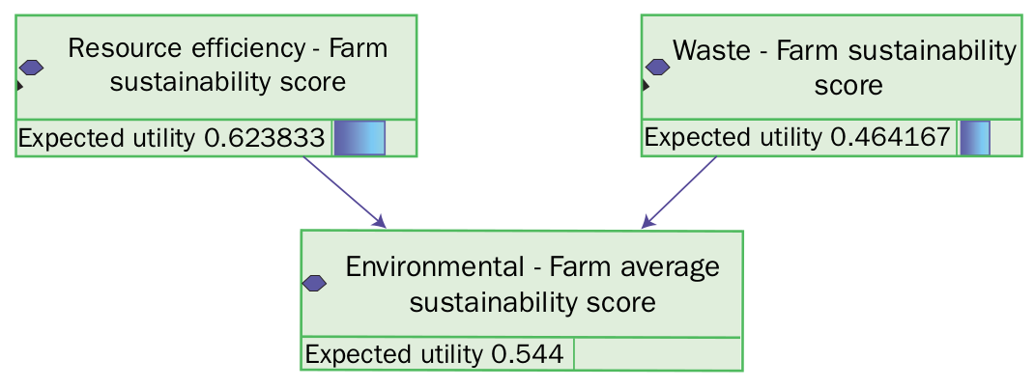**Figure 4:** Environmental elements of sustainability for the diary industry.

The impacts of different factors in the diary industry are depicted below as score cards. These can be used to help focus on agreed upon issues and inform other industry members. We can also inform the potential outcomes of different scenarios by setting known circumstances within the model to see how the outcomes will change.

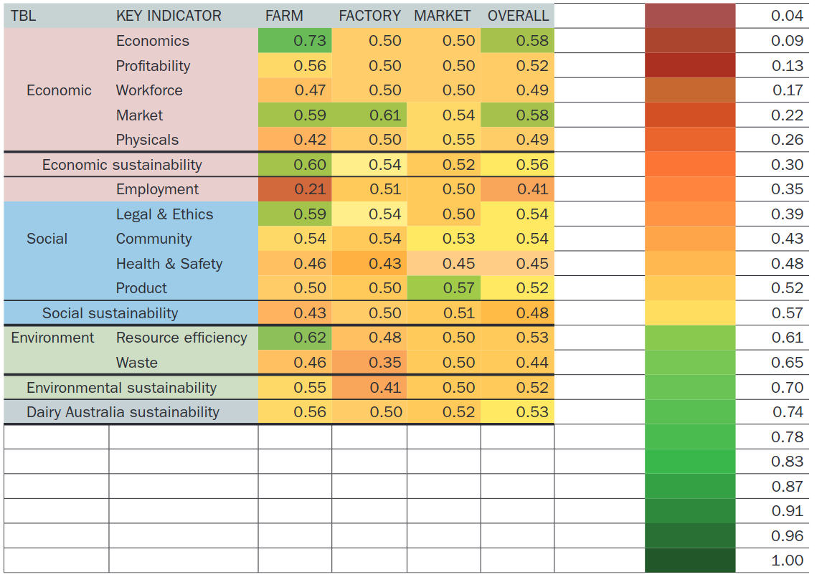**Figure 2:** Dairy Australia sustainability scorecard created using the expert informed Bayesian Network. The example is taken from *A Triple Bottom Line Planning Tool for Measuring Sustainability* by Laurie Buys, Kerrie Mengersen, Sandra Johnson, Neil Van Buuren and Evonne Miller.

**Strawman Bayesian Network for Vineyard Sustainability**

A strawman model is an initial example that can be used to demonstrate what we want to achieve and can be refined in the workshop by experts.

We present three sub-models for the Economic, Environmental and Social elements that make up sustainability in vineyards. We have used colour coding to represent the different nodes, where: **green** represents factors that have been well modelled using data. **red** represents factors that are not as predictable using data. And, **blue** are example factors not based on any data. To easily identify the end nodes, **pink** is used for triple bottom line nodes. The contributions of different elements to the final nodes economy, social, environment are also not based on any data.

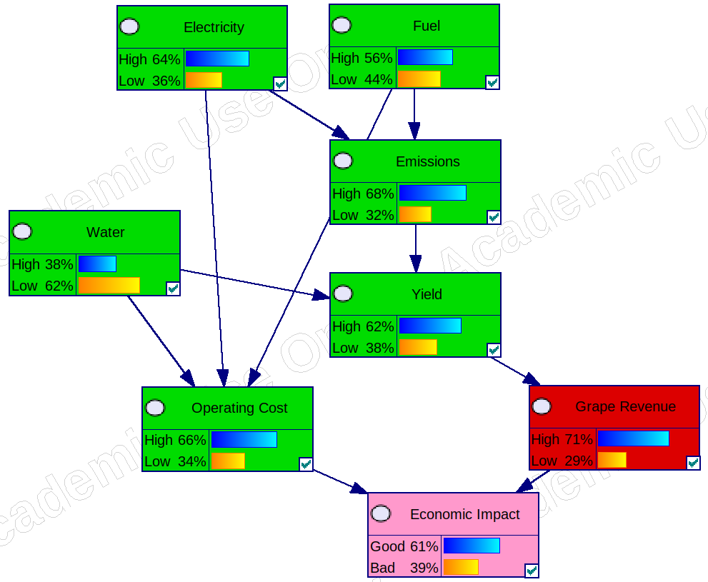**Figure 1:** Factors contributing to the economic impact on sustainability in vineyards.

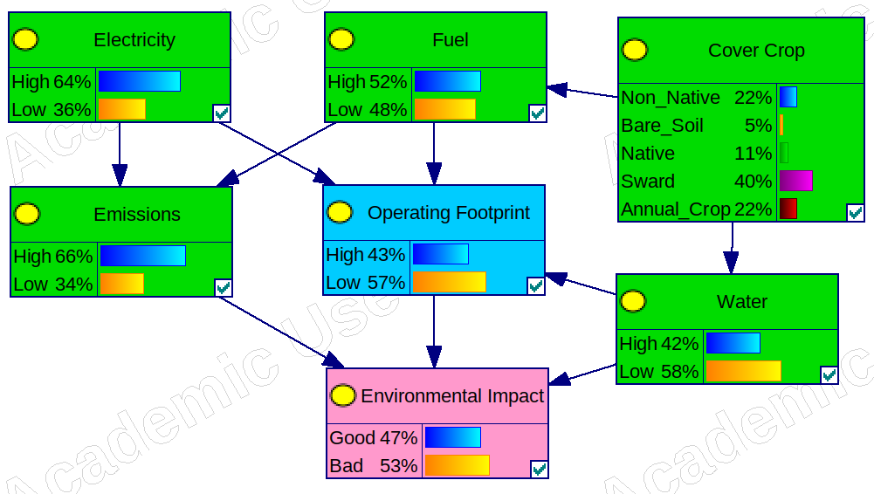**Figure 2:** Factors contributing to the environmental impact on sustainability in vineyards.

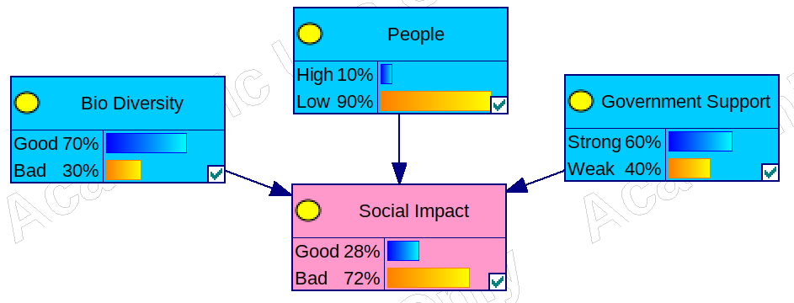**Figure 3:** Factors contributing to the social impact on sustainability in vineyards.

Combining each of the sub-models together we have a strawman model for estimating the impact of factors that influence sustainability in viticulture. Below we illustrate how each of the elements fit together. We also depict the level of influence each node has on each other by the thickness of the adjoining arrow.

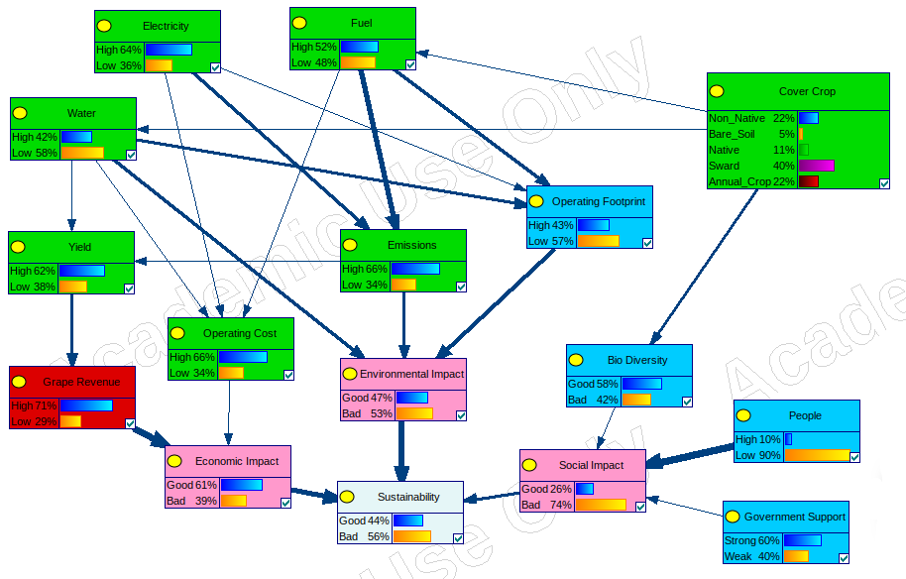**Figure 4:** The strawman model for sustainability in viticulture.